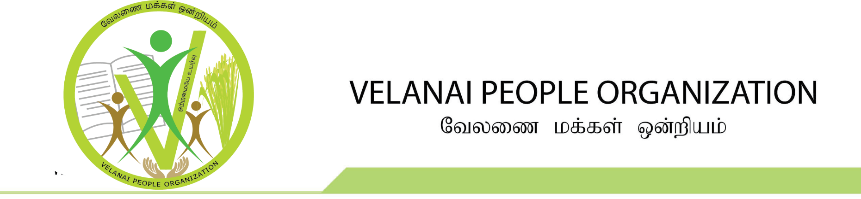

Registration No: 1661093

VPO’s Scholarship Application
You must:

- Complete the application by the deadline dates (September 15th, 2019)
- Verify that all information provided on the application is correct and complete
- Supporting documentations such as copy of report card must be provided by you

Applicant Information
Full Name: |  |  |  | DOB:
 | Last | First | M.I.

Address:
 | Street Address |  | Apartment/Unit #
 | City | State | ZIP Code

Phone: |  | Email

Education
High School: |  | Address:

Grade 12/CEGEP From: |  | To: |  | Did you graduate? | YES | NO

Grade 12 or CEGEP transcript
 | Subject | Grade
University Selection Subject 1:
University Selection Subject 2:
University Selection Subject 3:
University Selection Subject 4:
University Selection Subject 5:
University Selection Subject 6:
 | Average

Parents Information
Father Name:
 |  | Last |  |  |  |  | First |  |  |  | M.I.
Birth Place:
Mother Name:
 | Last |  |  |  |  | First |  |  |  | M.I.
Birth Place:
Supporting Details:

References

Please list at least one references.
Full Name: |  |  | Relationship:
Phone:
Full Name: |  |  | Relationship:
Phone:
Full Name: |  |  | Relationship:
Phone:

Disclaimer and Signature

Please review the Declaration and Notice of Collection, Use, Disclosure and Treatment of Personal Information provides as part of your application to Velanai People Organization (VPO). If you submit this application, you accept the terms and conditions in this statement.

I certify that my answers are true and complete to the best of my knowledge.
If this application leads to selection, I understand that false or misleading information in my application may result in immediate rejection.
I understand that by applying to this scholarship I agree all the decisions of the VPO scholarship committee are final and not subject to further appeal.

Signature: |  | Date:
Declaration and Notice of Collection, Use, Disclosure and Treatment of Personal Information provides as part of your application to Velanai People Organization (VPO).

We are committed to protecting your privacy in relation to the personal information you provide in support of your application.
By applying to Velanai People Organization Scholarship committee, you agree that your chosen VPO will obtain the personal information you provide to us and that we will collect, use, disclose and otherwise manage your personal information as set out in this Declaration and Notice.

Your Responsibilities
- Provide all the personal information requested in this application, along with your school report card and supporting documents, if applicable. VPO will not consider incomplete applications. VPO may require additional personal information and/or submissions to complete your application.
- Ensure that your application information and all supporting documentation is truthful, complete and correct. VPO reserve the right to verify any information provided as part of this application. If you withhold information or submit any information that is determined to be false, misleading, or written by a third party, we may, at our absolute discretion, invalidate the application, resulting in its immediate rejection or in the revocation.
- Submit your application no later than the specified deadline. Application received after deadline will not be considered.
- By applying to the scholarship, you agree that all the decision made by VPO scholarship committee are final and not subject to further appeal.
- Protect the personal information in your application and do not provide it to other organization in any form (e.g, paper, PDF).
- Attend the ceremony in person to receive the VPO’s scholarship.

Collection of Personal Information
- We will collect the personal information you provide in your application to process your application for Scholarship selection.
- We will collect the required information about your parents to confirm they are from Velanai.
- If your application is accepted, we will send a confirmation to your email address.

Conditions to apply

- One of the student’s parents must be born in Velanai
- Completed or will complete Grade 12 in Ontario or CEGEP in Quebec in 2019
- Student who applied to a Canadian University and accepted to enter fall 2019.
- Recipient must attend the ceremony in person to receive the VPO’s Scholarship

FREQUENTLY ASKED QUESTIONS

- What are the supporting details required on the Parents information?
These details are not always required but it will help VPO committee to easily confirm your parents are from Velanai.
- What is the purpose of reference and How do I choose?
The purpose of reference is to confirm your parents are from Velanai. It will help VPO committee to verify applicant background, if you choose VPO committee member or known person to VPO committee member.

